Example 1
Test User Login Validation
Problem Statement: Check whether login is successful when username and password are correct.
Expected Outcome:
Valid credentials > pass
Invalid credentials > fail
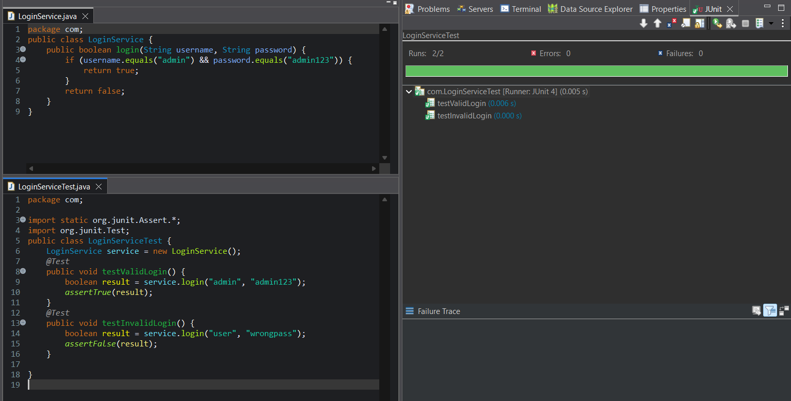
Example 2
Test Age Eligibility
Problem Statement: Verify whether a user is eligible to vote.
Expected Outcome:
Age ≥ 18 > eligible
Age < 18 > not eligible
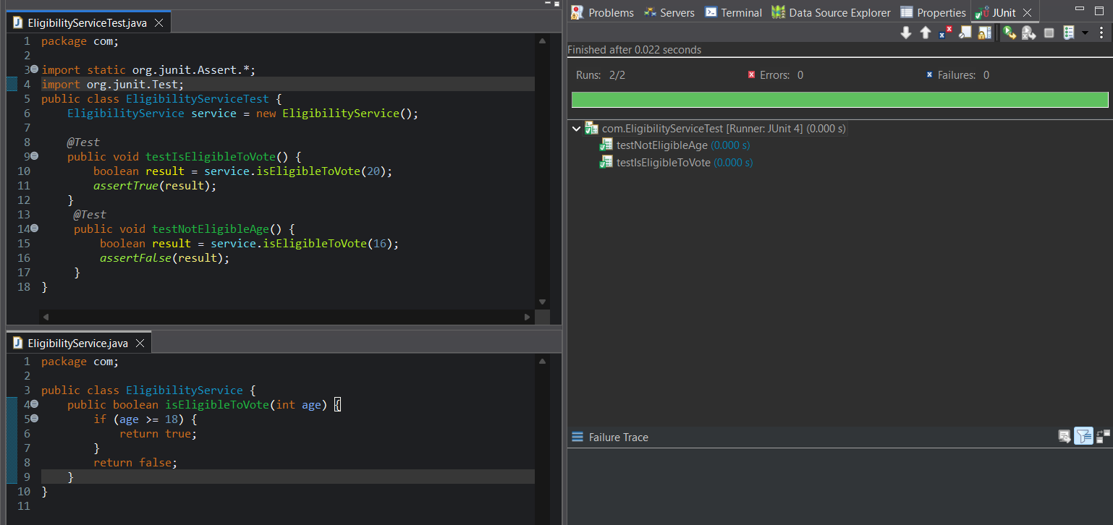
Example 3
Test String Uppercase Conversion
Problem Statement: Convert a string to uppercase and test the output.
Expected Outcome:
Input "java" > Output "JAVA"
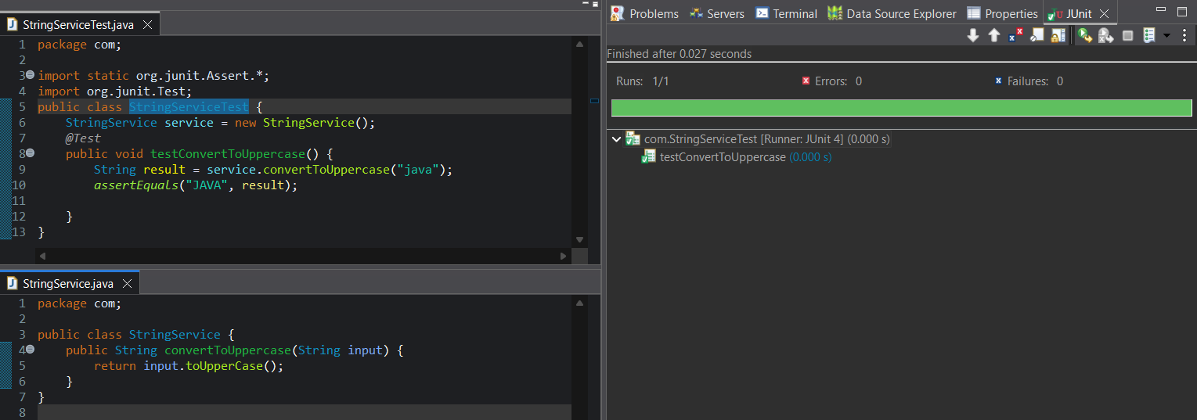
Example 4
Test Email Validation
Problem Statement: Check whether an email contains @ symbol.
Expected Outcome: Valid email passes test.
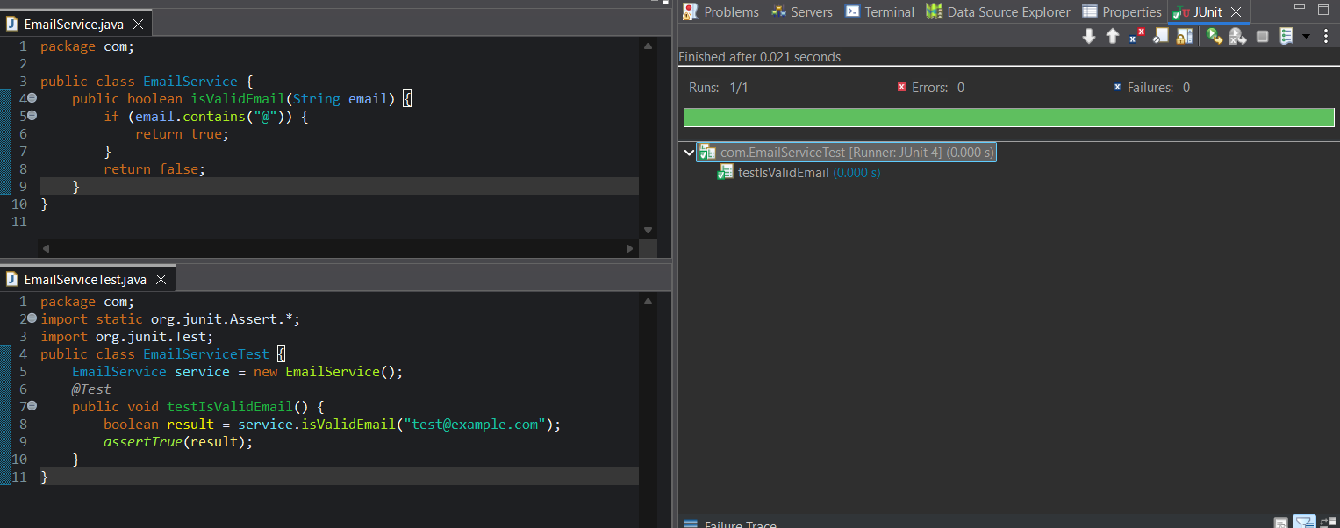

Example 5
Test Password Length Rule
Problem Statement: Check whether password length is at least 8 characters.
Expected Outcome: Short password fails.
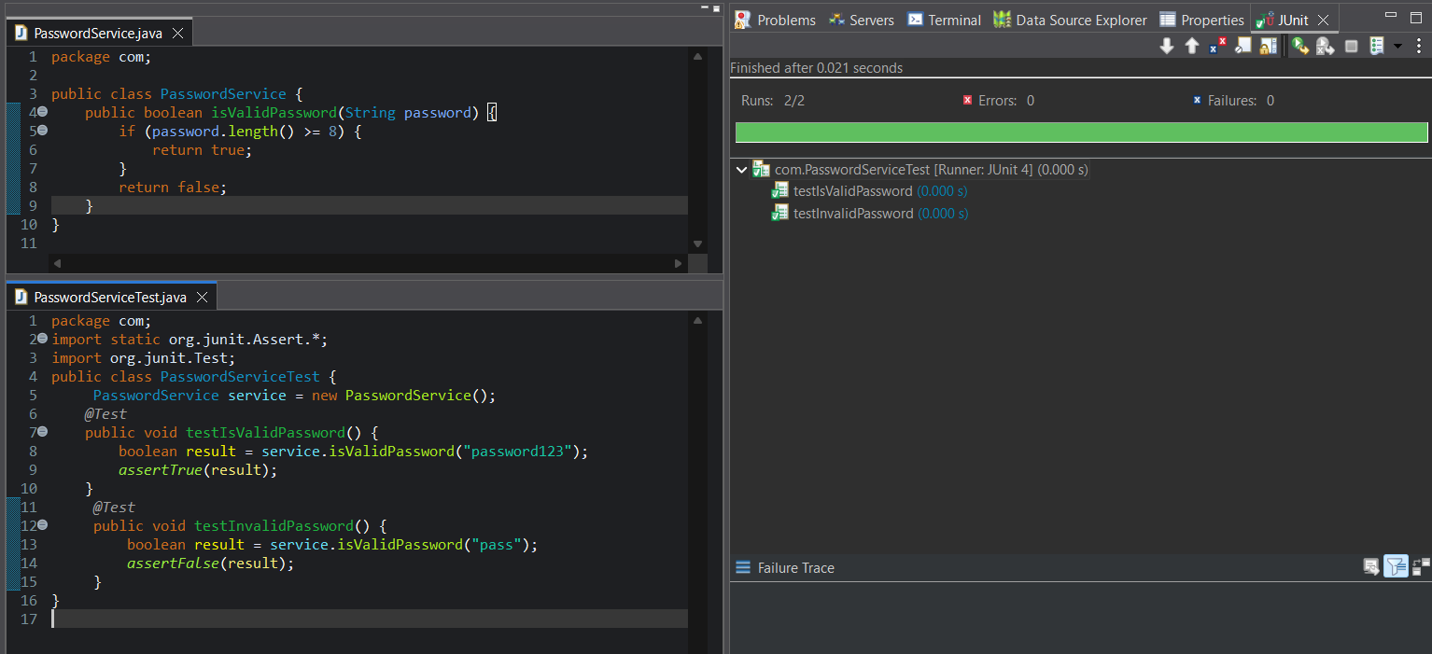
Example 6
Test File Name Extension
Problem Statement: Check whether file name ends with .csv.
Expected Outcome: CSV file passes test.
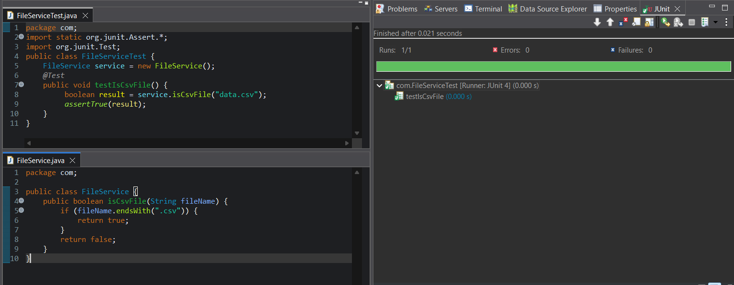

Example 7
Test Null Check
Problem Statement: Return a username and ensure it is not null.
Expected Outcome: Username should not be null.
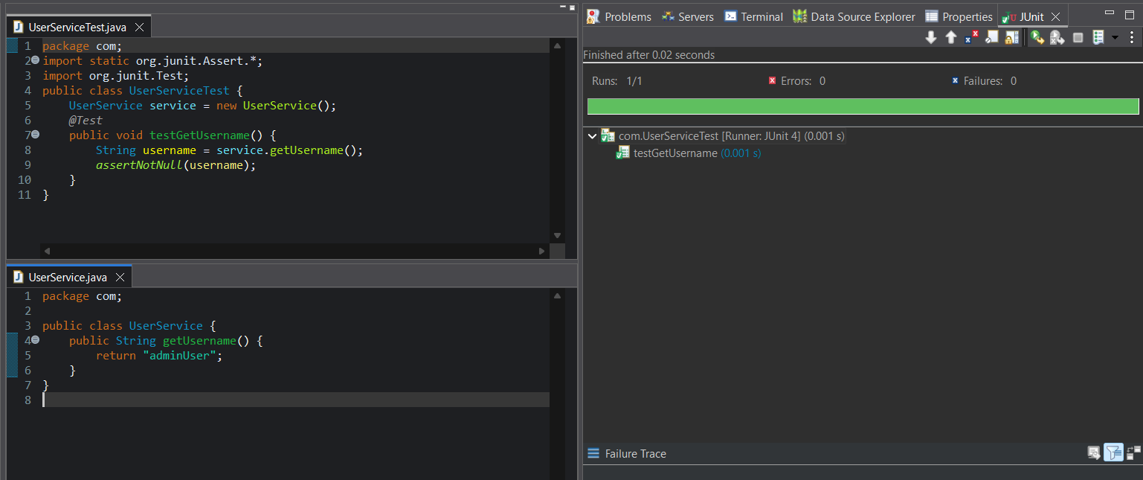
Example 8
Test List Size
Problem Statement: Add 3 items to a list and verify its size.
Expected Outcome: List size should be 3.
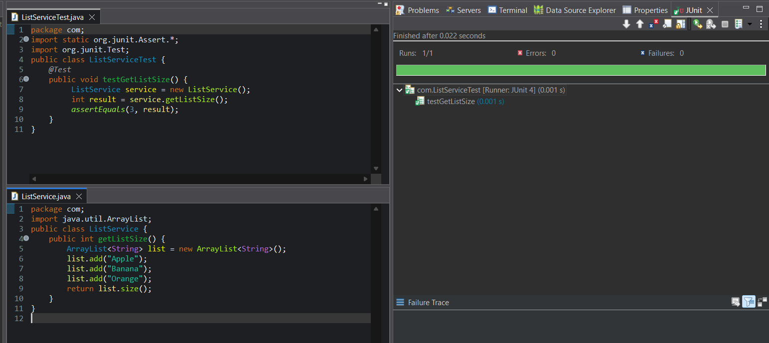

Example 9
Test Array Contains Value
Problem Statement: Check whether an array contains a specific value.
Expected Outcome: Value exists in array.
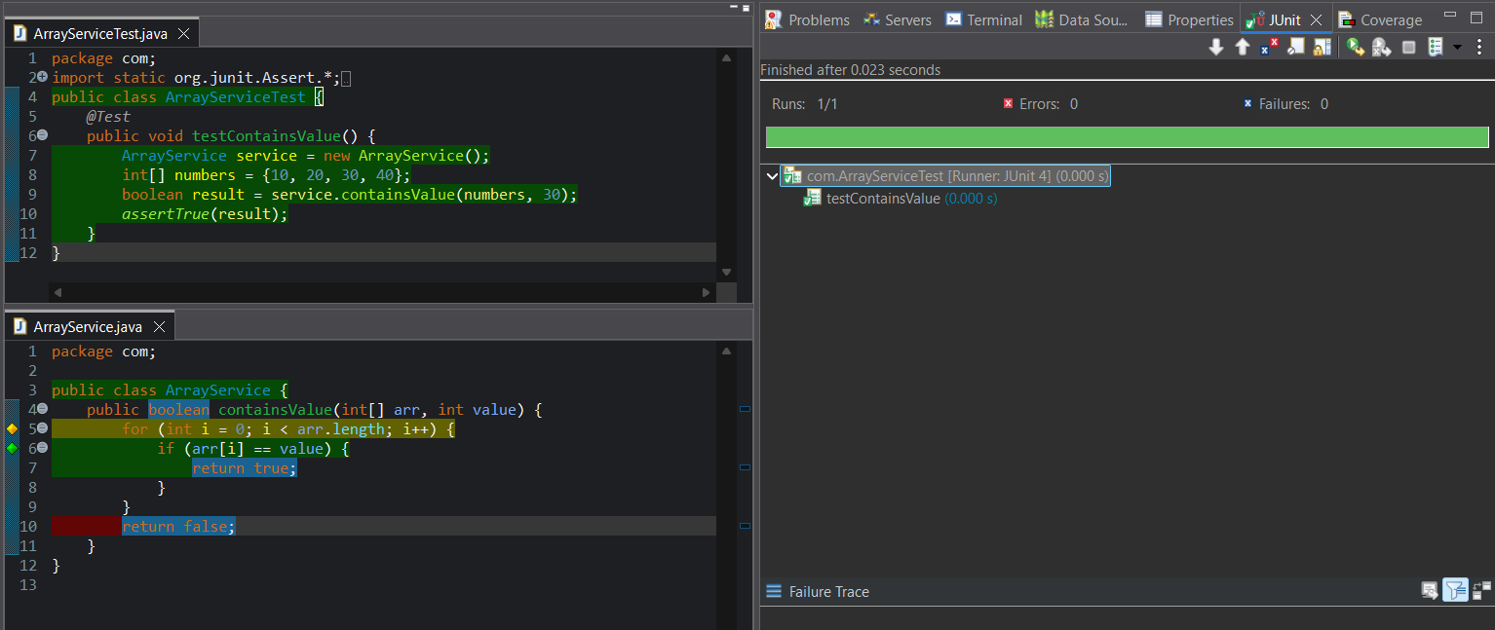
Example 10
Test Exception for Invalid Age
Problem Statement: Throw exception if age is negative.
Expected Outcome: Exception should be thrown
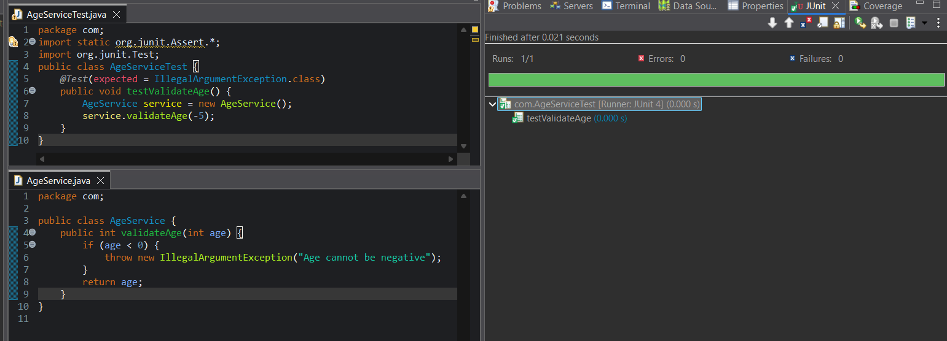

Example 11
Test Greeting Message
Problem Statement: Return greeting message based on username.
Expected Outcome: Message should match exactly.
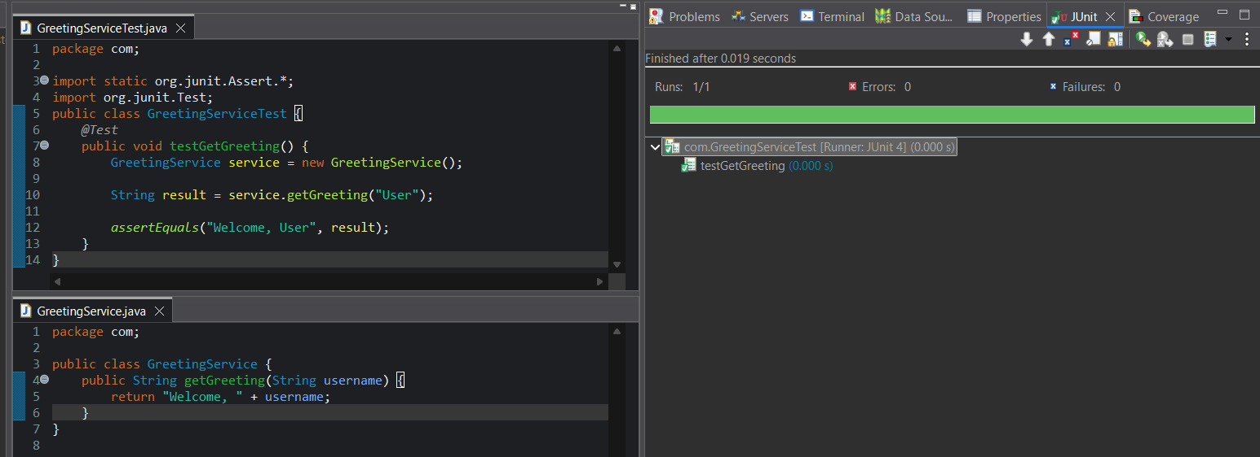
Example 12
Test Boolean Flag
Problem Statement: Return true if user is active.
Expected Outcome: Active user returns true.
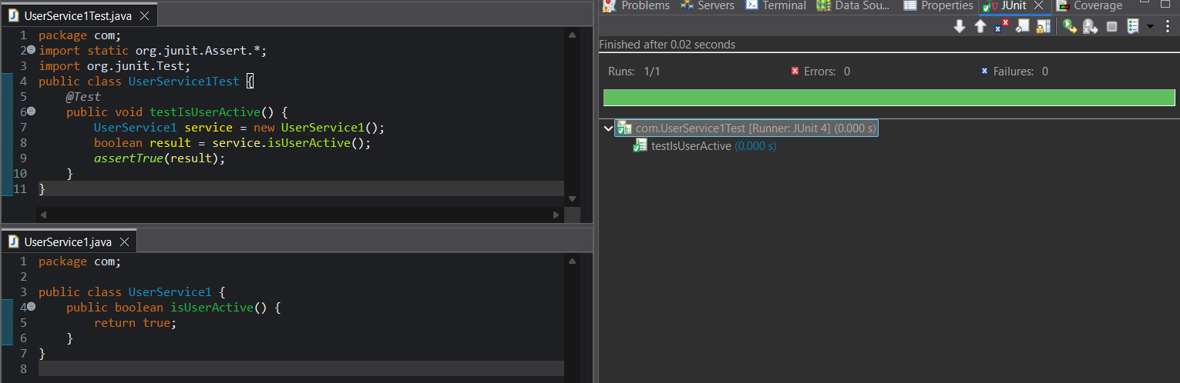

Example 13
Test Character Count
Problem Statement: Count characters in a string.
Expected Outcome: Correct character count returned.
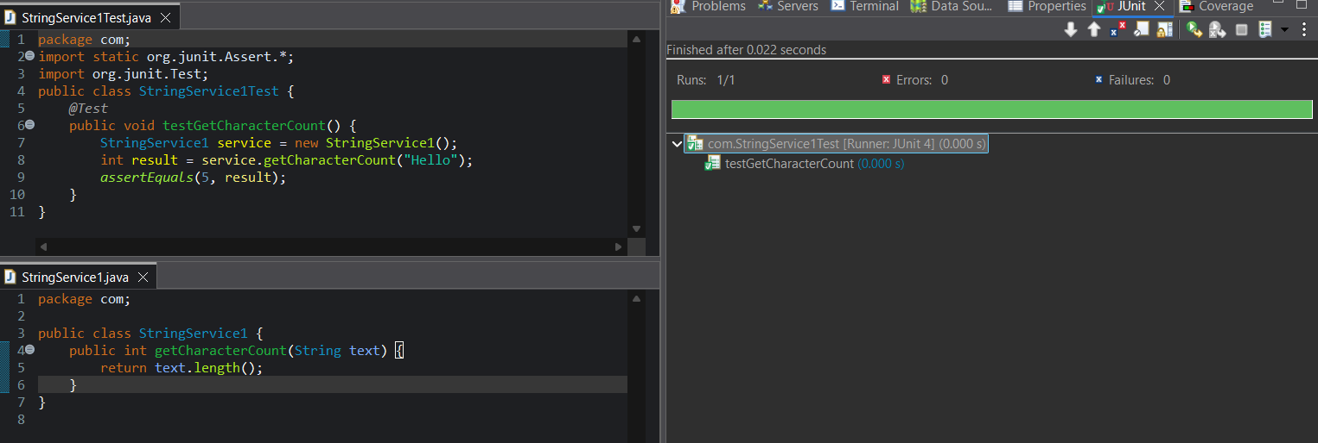
Example 14
Test Default Value
Problem Statement: Return default country code.
Expected Outcome: Country code matches.
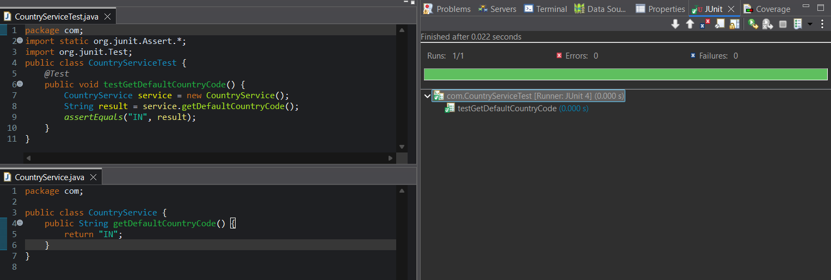

Example 15
Test Data Present Flag
Problem Statement: Check whether data exists.
Expected Outcome: Data presence validated.
